Assessment Task 2 - Crozzle Creation

Zhouhui Wu

216036381

Table of Contents

**Introduction3**

Basic introduction3

GUI and Manual (Brief)3

**Marking test 18**

Summary8

Input8

Output8

**Marking test 210**

Summary10

Input10

Output10

**Marking test 313**

Summary13

Input13

Output13

**Appendix15**

Marking test 115

Marking test 217

Marking test 321

Introduction

1. Basic introduction

This application is designed by Zhouhui Wu for SIT 323 assignment 2. Beside file reading and crozzle validating methods, it also contains crozzle generation methods, remote file reading methods and optimization techniques.

Here is detail information of the functions of this information:

* loading data from three files related to configuration, allowable words, and a

completed crozzle,

* validating/invalidating the three input data files
* validating/invalidating a crozzle that is described in these files,
* computing the score of a crozzle,
* displaying that crozzle and its score,
* coding to conventions and standards,
* coding unit tests,
* implementing menus, file dialogs, web browser(s) and regular expressions, and

creating a portfolio document;

* loading data from three files
* related to creating a new crozzle such that its score is valid and is the highest possible that you can achieve, ensuring that this new crozzle is valid,
* saving this new crozzle to a file, optimisation techniques,
* appropriate scoping of code elements,
* method characteristics such as cohesion and coupling,
* the usage of return statements,
* implementing exception handling, and
* creating a portfolio document;

1. GUI and Manual (Brief)

In this application, many components are used, including:

1. Menu Strip
2. Tab Control
3. Open File Dialog
4. Web Browser Controls * 2
5. Message Box

The basic user interface is shown in the picture below:

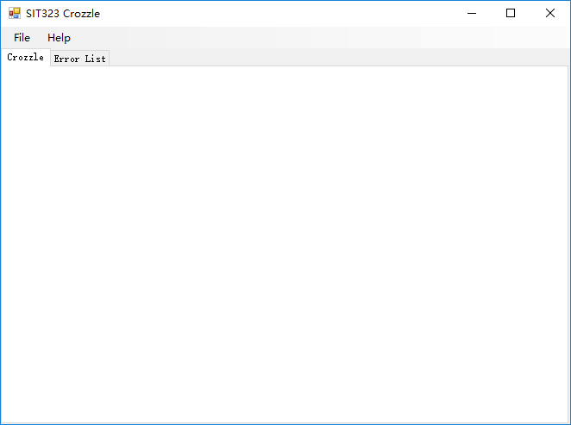

When click ‘File’ in the Menu Strip and ‘Load Crozzle’ in the File Menu, a OpenFileDialog will appeared:

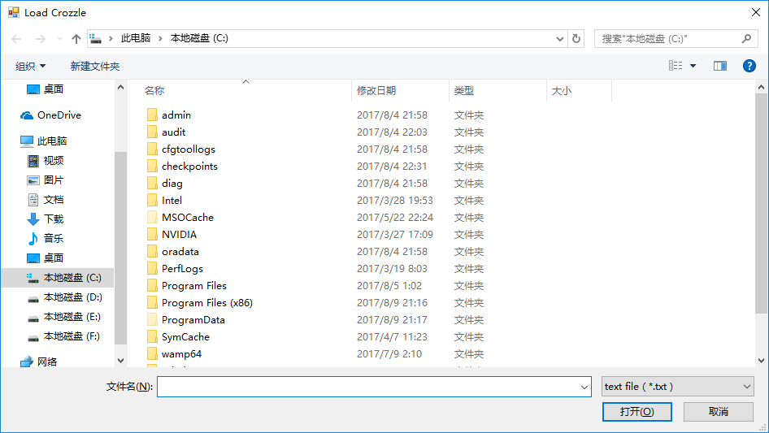

After choosing crozzle file, the crozzle will displayed in the ‘Crozzle’ panel of the application and score of crozzle will be calculated automatically:

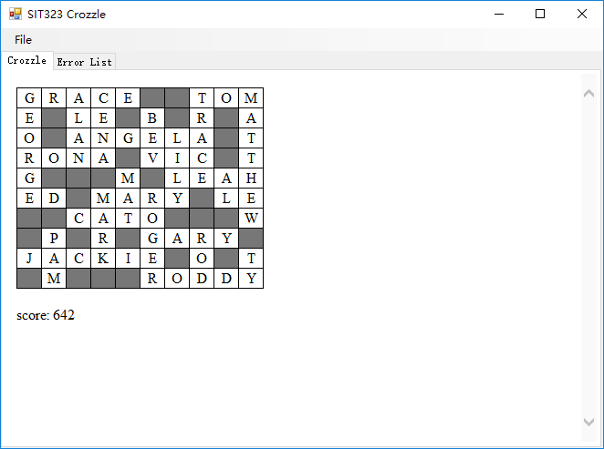

If the crozzle files (crozzle,txt, configuration.txt and wordlist.txt) contains errors, the application will try display crozzle in the ‘Crozzle’ panel and shown all errors it finds in the ‘Error List’ panel:

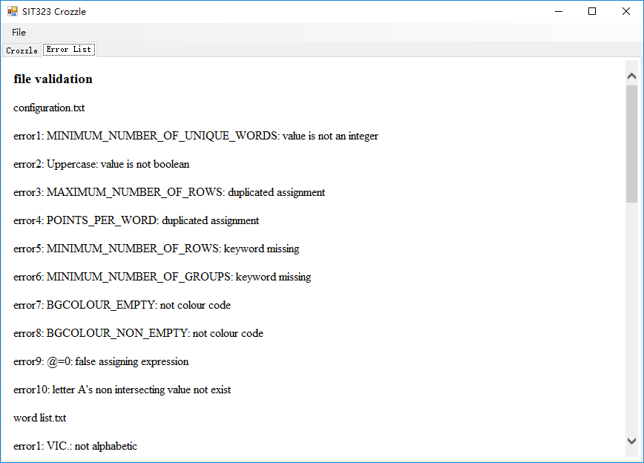

Errors will displayed in the order of File Validation (configuration.txt->wordlist.txt->crozzle.txt) -> Crozzle Validation.

When choosing a wrong crozzle file to load, it will display a message box, showing that there are problems occur when reading the crozzle file:

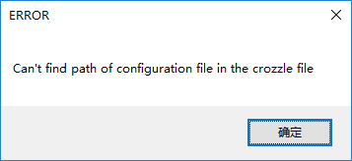

**When clicking ‘Create Crozzle’ and entering the correct url of czl file, the application will start finding high score crozzle. It will not stop until it use 5 minutes or all possibilities have been checked. After calculation, the result will show in the web browser as following.**

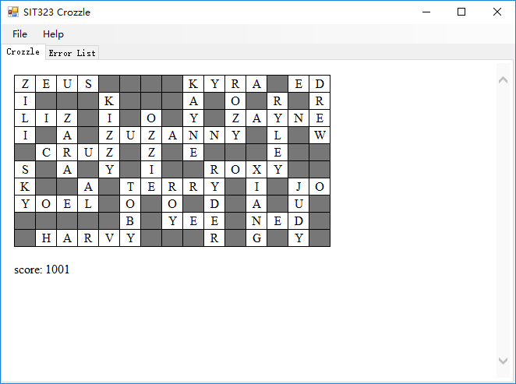

**After creating crozzle, save crozzle function provide function to save crozzle information to czl file. The saved czl file can be later opened by clicking ‘Load Crozzle.czl’. Like loading crozzle by txt, it will still provide crozzle validation functions to check if the crozzle meet requirements. Following picture is a picture of saved czl file.**

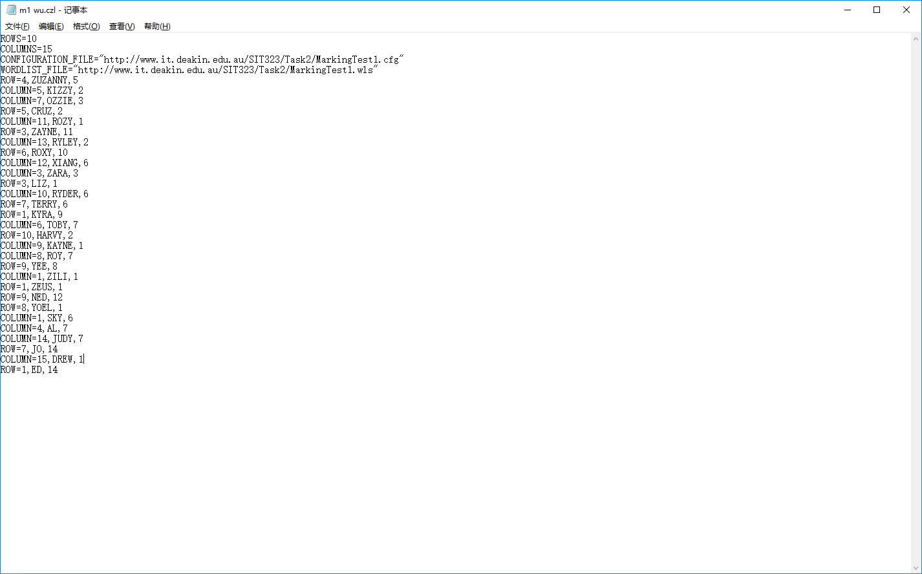

Marking test 1

Summary:

In marking test 1, it has a 10 * 15 grid and require 2 group of words. It took me long time to think of an idea of create a crozzle with 2 groups of words. After trying different methods, I finally meet all these requirements by created a crozzle with 2 groups of words and a score of 1001.

Input: (file details will be shown in the appendix part)

* 1. Marking 1 Configuration.cfg
  2. Marking 1 Crozzle.czl
  3. Marking 1 Wordlist.wls

Output:

Crozzle and Score:



(Score: 1001)

Words used in crozzle:

ROW=4,ZUZANNY,5

COLUMN=5,KIZZY,2

COLUMN=7,OZZIE,3

ROW=5,CRUZ,2

COLUMN=11,ROZY,1

ROW=3,ZAYNE,11

COLUMN=13,RYLEY,2

ROW=6,ROXY,10

COLUMN=12,XIANG,6

COLUMN=3,ZARA,3

ROW=3,LIZ,1

COLUMN=10,RYDER,6

ROW=7,TERRY,6

ROW=1,KYRA,9

COLUMN=6,TOBY,7

ROW=10,HARVY,2

COLUMN=9,KAYNE,1

COLUMN=8,ROY,7

ROW=9,YEE,8

COLUMN=1,ZILI,1

ROW=1,ZEUS,1

ROW=9,NED,12

ROW=8,YOEL,1

COLUMN=1,SKY,6

COLUMN=4,AL,7

COLUMN=14,JUDY,7

ROW=7,JO,14

COLUMN=15,DREW,1

ROW=1,ED,14

CZL File Saved:

ROWS=10

COLUMNS=15

CONFIGURATION_FILE="http://www.it.deakin.edu.au/SIT323/Task2/MarkingTest1.cfg"

WORDLIST_FILE="http://www.it.deakin.edu.au/SIT323/Task2/MarkingTest1.wls"

ROW=4,ZUZANNY,5

COLUMN=5,KIZZY,2

COLUMN=7,OZZIE,3

ROW=5,CRUZ,2

COLUMN=11,ROZY,1

ROW=3,ZAYNE,11

COLUMN=13,RYLEY,2

ROW=6,ROXY,10

COLUMN=12,XIANG,6

COLUMN=3,ZARA,3

ROW=3,LIZ,1

COLUMN=10,RYDER,6

ROW=7,TERRY,6

ROW=1,KYRA,9

COLUMN=6,TOBY,7

ROW=10,HARVY,2

COLUMN=9,KAYNE,1

COLUMN=8,ROY,7

ROW=9,YEE,8

COLUMN=1,ZILI,1

ROW=1,ZEUS,1

ROW=9,NED,12

ROW=8,YOEL,1

COLUMN=1,SKY,6

COLUMN=4,AL,7

COLUMN=14,JUDY,7

ROW=7,JO,14

COLUMN=15,DREW,1

ROW=1,ED,14

Marking test 2

Summary:

In marking test 2, non intersecting points contain value. In this case, it’s quite different from marking file 1. After improving my optimization method, I can reach a high score finally.

Input: (file details will be shown in the appendix part)

1. Marking 2 Configuration.cfg
2. Marking 2 Crozzle.czl
3. Marking 2 Wordlist.wls

Output:

Crozzle and Score:

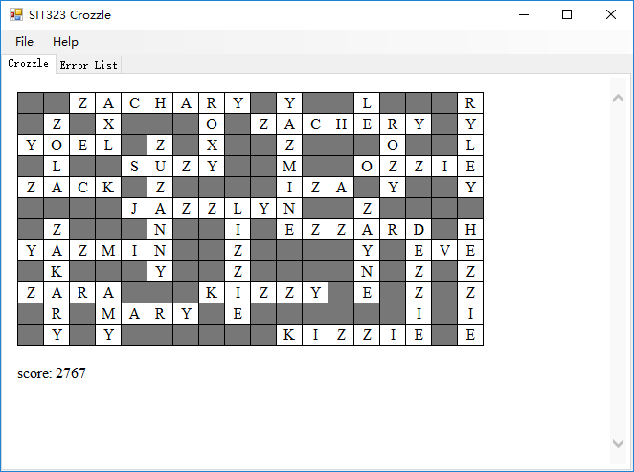

Score: 2767

Words used in crozzle:

ROW=6,JAZZLYN,5

COLUMN=6,ZUZANNY,3

COLUMN=9,LIZZIE,6

ROW=10,KIZZY,8

ROW=4,SUZY,5

COLUMN=11,YAZMINE,1

ROW=7,EZZARD,11

COLUMN=16,DEZZIE,7

ROW=12,KIZZIE,11

ROW=2,ZACHERY,10

COLUMN=14,ZAYNE,6

ROW=8,YAZMIN,1

COLUMN=2,ZAKARY,7

COLUMN=15,ROZY,2

ROW=10,ZARA,1

ROW=5,IZA,11

COLUMN=4,AMY,10

ROW=11,MARY,4

ROW=8,EVE,16

COLUMN=18,HEZZIE,7

COLUMN=8,ROXY,1

ROW=1,ZACHARY,3

COLUMN=4,AXL,1

ROW=3,YOEL,1

COLUMN=2,ZOLA,2

ROW=5,ZACK,1

ROW=4,OZZIE,14

COLUMN=18,RYLEY,1

COLUMN=14,LE,1

CZL File Saved:

ROWS=12

COLUMNS=18

CONFIGURATION_FILE="http://www.it.deakin.edu.au/SIT323/Task2/MarkingTest2.cfg"

WORDLIST_FILE="http://www.it.deakin.edu.au/SIT323/Task2/MarkingTest2.wls"

ROW=6,JAZZLYN,5

COLUMN=6,ZUZANNY,3

COLUMN=9,LIZZIE,6

ROW=10,KIZZY,8

ROW=4,SUZY,5

COLUMN=11,YAZMINE,1

ROW=7,EZZARD,11

COLUMN=16,DEZZIE,7

ROW=12,KIZZIE,11

ROW=2,ZACHERY,10

COLUMN=14,ZAYNE,6

ROW=8,YAZMIN,1

COLUMN=2,ZAKARY,7

COLUMN=15,ROZY,2

ROW=10,ZARA,1

ROW=5,IZA,11

COLUMN=4,AMY,10

ROW=11,MARY,4

ROW=8,EVE,16

COLUMN=18,HEZZIE,7

COLUMN=8,ROXY,1

ROW=1,ZACHARY,3

COLUMN=4,AXL,1

ROW=3,YOEL,1

COLUMN=2,ZOLA,2

ROW=5,ZACK,1

ROW=4,OZZIE,14

COLUMN=18,RYLEY,1

COLUMN=14,LE,1

Marking test 3

Summary:

In marking test 3, it has a small grid of 8 * 12. Also, in this test, all intersecting points and non intersecting points contain value and all words in word list is quite short. It is different from the first 2 test and after working on improving my optimization technique, I can reach a high score in this one.

Input: (file details will be shown in the appendix part)

1. Marking 3 Configuration.cfg
2. Marking 3 Crozzle.czl
3. Marking 3 Wordlist.wls

Output:

Crozzle and Score:

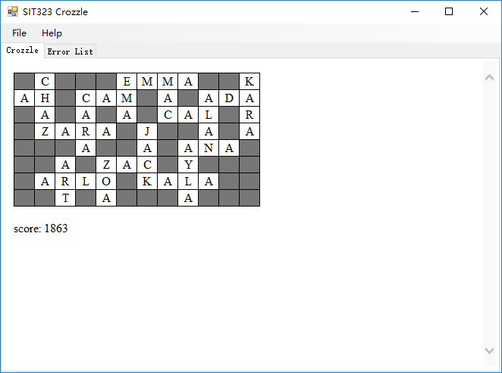

Score: 1863

Words used in crozzle:

ROW=4,ZARA,2

COLUMN=2,CHAZ,1

COLUMN=4,CARA,2

ROW=2,AH,1

ROW=2,CAM,4

COLUMN=6,EMA,1

ROW=1,EMMA,6

COLUMN=8,MAC,1

ROW=3,CAL,8

COLUMN=10,ALAN,2

ROW=5,ANA,9

ROW=2,ADA,10

COLUMN=12,KARA,1

COLUMN=9,AYLA,5

ROW=7,KALA,7

COLUMN=7,JACK,4

ROW=6,ZAC,5

COLUMN=5,ZOA,6

ROW=7,ARLO,2

COLUMN=3,ART,6

CZL File Saved:

ROWS=8

COLUMNS=12

CONFIGURATION_FILE="http://www.it.deakin.edu.au/SIT323/Task2/MarkingTest3.cfg"

WORDLIST_FILE="http://www.it.deakin.edu.au/SIT323/Task2/MarkingTest3.wls"

ROW=4,ZARA,2

COLUMN=2,CHAZ,1

COLUMN=4,CARA,2

ROW=2,AH,1

ROW=2,CAM,4

COLUMN=6,EMA,1

ROW=1,EMMA,6

COLUMN=8,MAC,1

ROW=3,CAL,8

COLUMN=10,ALAN,2

ROW=5,ANA,9

ROW=2,ADA,10

COLUMN=12,KARA,1

COLUMN=9,AYLA,5

ROW=7,KALA,7

COLUMN=7,JACK,4

ROW=6,ZAC,5

COLUMN=5,ZOA,6

ROW=7,ARLO,2

COLUMN=3,ART,6

Appendix:

1. Marking test 1:

(1). Marking 1 Configuration.cfg

// Log File Configurations.

// The default log file name.

LOGFILE_NAME="log.txt" // log file

// The runtime limit, in seconds.

RUNTIME_LIMIT=300 // 5 minutes

// Word List Configurations.

WORD_REGEX_PATTERN="[a-zA-Z]{2,}" // Characters allowed in a word.

// Limits on the size of the word list.

MINIMUM_NUMBER_OF_UNIQUE_WORDS=10

MAXIMUM_NUMBER_OF_UNIQUE_WORDS=1000

// Crozzle Output Configurations.

INVALID_CROZZLE_SCORE="INVALID CROZZLE"

UPPERCASE=true

STYLE="<style> table, td { border: 1px solid black; border-collapse: collapse; } td { width:24px; height:18px; text-align: center; } </style>"

BGCOLOUR_EMPTY_TD=#777777

BGCOLOUR_NON_EMPTY_TD=#ffffff

// Crozzle Configurations.

// Limits on the size of the crozzle grid.

MINIMUM_NUMBER_OF_ROWS=4

MAXIMUM_NUMBER_OF_ROWS=400

MINIMUM_NUMBER_OF_COLUMNS=8

MAXIMUM_NUMBER_OF_COLUMNS=800

// Limits on the number of horizontal words and

// vertical words in a crozzle.

MINIMUM_HORIZONTAL_WORDS=1

MAXIMUM_HORIZONTAL_WORDS=1000

MINIMUM_VERTICAL_WORDS=1

MAXIMUM_VERTICAL_WORDS=1000

// Limits on the number of

// intersecting vertical words for each horizontal word, and

// intersecting horizontal words for each vertical word.

MINIMUM_INTERSECTIONS_IN_HORIZONTAL_WORDS=1

MAXIMUM_INTERSECTIONS_IN_HORIZONTAL_WORDS=100

MINIMUM_INTERSECTIONS_IN_VERTICAL_WORDS=1

MAXIMUM_INTERSECTIONS_IN_VERTICAL_WORDS=100

// Limits on duplicate words in the crozzle.

MINIMUM_NUMBER_OF_THE_SAME_WORD=1

MAXIMUM_NUMBER_OF_THE_SAME_WORD=1

// Limits on the number of valid word groups.

MINIMUM_NUMBER_OF_GROUPS=2

MAXIMUM_NUMBER_OF_GROUPS=2

// Scoring Configurations

// The number of points per word within the crozzle.

POINTS_PER_WORD=10

// Points per letter that is at the intersection of

// a horizontal and vertical word within the crozzle.

INTERSECTING_POINTS_PER_LETTER="A=1,B=2,C=2,D=2,E=1,F=2,G=2,H=2,I=1,J=4,K=4,L=4,M=4,N=4,O=1,P=8,Q=8,R=8,S=8,T=8,U=1,V=16,W=16,X=32,Y=32,Z=64"

// Points per letter that is not at the intersection of

// a horizontal and vertical word within the crozzle.

NON_INTERSECTING_POINTS_PER_LETTER="A=0,B=0,C=0,D=0,E=0,F=0,G=0,H=0,I=0,J=0,K=0,L=0,M=0,N=0,O=0,P=0,Q=0,R=0,S=0,T=0,U=0,V=0,W=0,X=0,Y=0,Z=0"

(2). Marking 1 Crozzle.czl

// File dependencies.

// Configuraton file.

CONFIGURATION_FILE="http://www.it.deakin.edu.au/SIT323/Task2/MarkingTest1.cfg"

// Word list file.

WORDLIST_FILE="http://www.it.deakin.edu.au/SIT323/Task2/MarkingTest1.wls"

// Crozzle Size.

// The number of rows and columns.

ROWS=10

COLUMNS=15

(3). Marking 1 Wordlist.wls

AADEN,AARON,AL,ALAN,ALEX,ALEXANDRA,ALEXIA,ALI,ALLA,AMY,ANTHONY,ARLA,ARLY,ARMIDA,ARVIL,ASHELY,ASHLEE,ASHLYN,ASHTYN,ATHENA,AUBRIE,AURORA,AUSTIN,AYDEN,BAXTER,BELINDA,BEV,BEVERLEY,BLAZE,BOBBY,BRENDA,BRIGGS,BROOK,BROOKS,BRYCEN,BRYSEN,BUDDIE,BUFORD,BURNIE,BUSTER,BYNUM,CAIDEN,CALLAN,CAM,CARA,CAYLEE,CLIVE,CONWAY,CRAIG,CRISTINA,CROSBY,CRUZ,CRYSTAL,DALE,DAN,DAVID,DAVY,DAWN,DEANNE,DEB,DEBERA,DEE,DEETTA,DELCIE,DELINA,DELLIE,DELORA,DELSIE,DENZIL,DEZZIE,DOM,DOT,DREMA,DREW,DWAIN,DWAYNE,ED,EDITH,EDWARD,ELIZABET,ELIZABETH,ELWOOD,EMILEE,ENZO,ERICA,ERLINE,ERMINA,ERNEST,ESTELA,ESTHER,EUDORA,EUGENE,EVA,EVALYN,EVE,EVELIN,EVELYN,EVETTE,EVONNE,EZZARD,FALLON,FANNIE,FANNYE,FARRAH,FATIMA,FELICE,FELIPA,FRED,GIOVANNY,GRAHAM,GWEN,HARVY,HOPE,HUEY,IAN,ISA,IVAN,IVON,IZA,JACK,JAKE,JILL,JO,JUDY,KARA,KARL,KAY,KAYE,KAYLAN,KAYLEE,KAYNE,KELVIN,KENT,KERRI,KEVIN,KIZZIE,KIZZY,KOBY,KODY,KRIS,KYLE,KYRA,LANCE,LE,LEEROY,LENNOX,LEO,LEON,LES,LEWIS,LILA,LIZ,LIZZIE,LOC,LOU,LU,LUCILE,LULU,LUZ,MABELL,MABELLE,MADALYN,MADALYNN,MADDEN,MADISON,MAEGAN,MAGNUS,MALISSA,MALLORY,MANNING,MARCELLO,MARIAH,MARK,MARLIN,MARYANNE,MAVERICK,MEGAN,MELISSA,MELONY,MEREDITH,MERVIN,MICHELLE,MILLER,MITCHELL,MOE,MONICA,MURPHY,MURRAY,NED,NEIL,NEWTON,NOEL,OMAR,OSCAR,OWENS,OZZIE,PAM,PENNY,PHEBE,QUINTY,RAE,RAY,REMI,RENTON,RICHARD,ROD,RON,ROXANA,ROXANNE,ROXIE,ROXY,ROY,ROZY,RYDER,RYLEY,SABRINA,SAL,SALLY,SAM,SAMANTHA,SAMPSON,SARAH,SAWYER,SHAKIRA,SHAUN,SHELDON,SKY,SOPHIE,STEPHEN,STEVEN,SUSAN,SYLVIA,TAI,TAMARA,TAMMIE,TAMMY,TARA,TATIANNA,TAYLOR,TAYSHAUN,TED,TEMPERANCE,TENLEY,TENNESSEE,TENNILLE,TERRANCE,TERRI,TERRIE,TERRY,THOMASINA,THOMPSON,TIFFANIE,TIFFANNY,TIMMOTHY,TINA,TOBY,TOM,TREVOR,TRISHA,TRUDY,TYREE,TYRONE,VAL,VELVET,VERA,VERN,VIC,VICK,VICKY,VICTOR,VON,WALLY,WALT,WENDY,WES,WHITNEY,WILLY,XAVIER,XENA,XIANG,YASMIN,YAZMIN,YAZMINE,YEE,YOEL,YOKO,YORK,YUSUF,ZACHARY,ZACK,ZANDRA,ZARA,ZAYNE,ZELDA,ZELIA,ZENA,ZEUS,ZIGMUND,ZILI,ZUZANNY

1. Marking test 2:

(1). Marking 2 Configuration.cfg

// Log File Configurations.

// The default log file name.

LOGFILE_NAME="log.txt" // log file

// The runtime limit, in seconds.

RUNTIME_LIMIT=300 // 5 minutes

// Word List Configurations.

WORD_REGEX_PATTERN="[a-zA-Z]{2,}" // Characters allowed in a word.

// Limits on the size of the word list.

MINIMUM_NUMBER_OF_UNIQUE_WORDS=10

MAXIMUM_NUMBER_OF_UNIQUE_WORDS=1000

// Crozzle Output Configurations.

INVALID_CROZZLE_SCORE="INVALID CROZZLE"

UPPERCASE=true

STYLE="<style> table, td { border: 1px solid black; border-collapse: collapse; } td { width:24px; height:18px; text-align: center; } </style>"

BGCOLOUR_EMPTY_TD=#777777

BGCOLOUR_NON_EMPTY_TD=#ffffff

// Crozzle Configurations.

// Limits on the size of the crozzle grid.

MINIMUM_NUMBER_OF_ROWS=4

MAXIMUM_NUMBER_OF_ROWS=400

MINIMUM_NUMBER_OF_COLUMNS=8

MAXIMUM_NUMBER_OF_COLUMNS=800

// Limits on the number of horizontal words and

// vertical words in a crozzle.

MINIMUM_HORIZONTAL_WORDS=1

MAXIMUM_HORIZONTAL_WORDS=1000

MINIMUM_VERTICAL_WORDS=1

MAXIMUM_VERTICAL_WORDS=1000

// Limits on the number of

// intersecting vertical words for each horizontal word, and

// intersecting horizontal words for each vertical word.

MINIMUM_INTERSECTIONS_IN_HORIZONTAL_WORDS=1

MAXIMUM_INTERSECTIONS_IN_HORIZONTAL_WORDS=100

MINIMUM_INTERSECTIONS_IN_VERTICAL_WORDS=1

MAXIMUM_INTERSECTIONS_IN_VERTICAL_WORDS=100

// Limits on duplicate words in the crozzle.

MINIMUM_NUMBER_OF_THE_SAME_WORD=1

MAXIMUM_NUMBER_OF_THE_SAME_WORD=1

// Limits on the number of valid word groups.

MINIMUM_NUMBER_OF_GROUPS=1

MAXIMUM_NUMBER_OF_GROUPS=1

// Scoring Configurations

// The number of points per word within the crozzle.

POINTS_PER_WORD=10

// Points per letter that is at the intersection of

// a horizontal and vertical word within the crozzle.

INTERSECTING_POINTS_PER_LETTER="A=0,B=0,C=0,D=0,E=0,F=0,G=0,H=0,I=0,J=0,K=0,L=0,M=0,N=0,O=0,P=0,Q=0,R=0,S=0,T=0,U=0,V=0,W=0,X=0,Y=0,Z=0"

// Points per letter that is not at the intersection of

// a horizontal and vertical word within the crozzle.

NON_INTERSECTING_POINTS_PER_LETTER="A=1,B=2,C=2,D=2,E=1,F=2,G=2,H=2,I=1,J=4,K=4,L=4,M=4,N=4,O=1,P=8,Q=8,R=8,S=8,T=8,U=1,V=16,W=16,X=32,Y=32,Z=64"

(2). Marking 2 Crozzle.czl

// File dependencies.

// Configuraton file.

CONFIGURATION_FILE="http://www.it.deakin.edu.au/SIT323/Task2/MarkingTest2.cfg"

// Word list file.

WORDLIST_FILE="http://www.it.deakin.edu.au/SIT323/Task2/MarkingTest2.wls"

// Crozzle Size.

// The number of rows and columns.

ROWS=12

COLUMNS=18

(3). Marking 2 Wordlist.wls

AADEN,AANYA,AARON,AL,ALAN,ALEX,ALEXANDER,ALEXANDRA,ALEXIA,ALI,ALLA,ALLAN,ALLY,AMY,ANDREW,ANN,ANNE,ANTHONY,ARJUN,ARLA,ARLO,ARLY,ARMANI,ARMIDA,ARNOLD,ARTHUR,ARVIL,ARYANA,ASH,ASHELY,ASHLEA,ASHLEE,ASHLEIGH,ASHLEY,ASHLIE,ASHLYN,ASHTON,ASHTYN,ASTRID,ATHENA,AUBREE,AUBREY,AUBRIE,AUDREY,AURORA,AURORE,AUSTIN,AXL,AYDEN,AYLA,BAXTER,BEATRIX,BELINDA,BEN,BETTY,BEV,BEVERLEY,BILL,BLAZE,BOB,BOBBY,BORIS,BRENDA,BRIGGS,BRODIE,BROGAN,BROOK,BROOKS,BRUNO,BRYANT,BRYCEN,BRYSEN,BRYSON,BRYTON,BUDDIE,BUFORD,BURLEY,BURNEY,BURNIE,BURREL,BURTON,BUSTER,BUTLER,BYNUM,CAESAR,CAIDEN,CALLAN,CAM,CARA,CATHERINE,CAYLEE,CHAZ,CLIVE,CON,CONNOR,CONWAY,COOPER,CRAIG,CRIS,CRISSIE,CRISTINA,CROSBY,CRUZ,CRYSTAL,DALE,DAN,DAVE,DAVID,DAVY,DAWN,DAYANA,DEANNA,DEANNE,DEASIA,DEB,DEBBIE,DEBBRA,DEBERA,DEBORA,DEBRAH,DEE,DEEANN,DEEDEE,DEETTA,DEIDRA,DEIDRE,DELCIE,DELIAH,DELILA,DELINA,DELISA,DELLAR,DELLIA,DELLIE,DELOIS,DELORA,DELPHA,DELSIE,DENNIS,DENZIL,DEXTER,DEZZIE,DOM,DON,DOT,DREMA,DREW,DWAIN,DWANE,DWAYNE,ED,EDDY,EDITH,EDWARD,EILEEN,ELIZABET,ELIZABETH,ELVIS,ELWOOD,EMILEE,EMMA,ENZO,ERICA,ERLENE,ERLINE,ERMINA,ERMINE,ERNEST,ERYKAH,ESTELA,ESTELL,ESTHER,ETHYLE,EUDORA,EUGENE,EUNICE,EVA,EVALYN,EVAN,EVE,EVELIN,EVELYN,EVERLY,EVETTE,EVONNE,EZZARD,FALLON,FANNIE,FANNYE,FARRAH,FATIMA,FAWN,FELICE,FELIPA,FINLEY,FRED,GARY,GIOVANNY,GLENDA,GRAHAM,GREG,GWEN,GWYN,HARVY,HEZZIE,HOPE,HOWARD,HUEY,HUXLEY,IAN,ISA,IVA,IVAN,IVON,IZA,JACK,JAKE,JAQUELINE,JAZZLYN,JILL,JIM,JO,JOHN,JUDITH,JUDY,KALA,KALE,KARA,KARI,KARL,KAY,KAYE,KAYLAH,KAYLAN,KAYLEE,KAYLEN,KAYNE,KELVIN,KENT,KERI,KERRI,KEVIN,KING,KIZZIE,KIZZY,KOBY,KODY,KORY,KRIS,KURT,KYLE,KYRA,LANCE,LE,LEEROY,LENNOX,LEO,LEON,LES,LEWIS,LEXI,LILA,LIZ,LIZZIE,LOC,LOU,LU,LUCILE,LULU,LUZ,MABELL,MABELLE,MADALINE,MADALYN,MADALYNN,MADDEN,MADISON,MADORA,MAEGAN,MAGGIE,MAGNUS,MAL,MALISSA,MALLORIE,MALLORY,MALORIE,MANNING,MARCELLA,MARCELLO,MARGARET,MARGERET,MARIAH,MARIAN,MARIANNE,MARK,MARKUS,MARLIN,MARSHALL,MARY,MARYANNE,MATHEW,MATTHEW,MAVERICK,MAVIS,MAY,MEGAN,MELISSA,MELLISSA,MELONIE,MELONY,MEREDITH,MERVIN,MERVYN,MICHAEL,MICHELLE,MICK,MICKEY,MILDRED,MILLER,MILTON,MIRANDA,MITCHELL,MOE,MONICA,MONIKA,MORIAH,MURPHY,MURRAY,NAOMI,NED,NEIL,NEWTON,NOE,NOEL,OLIVE,OMAR,ORAN,OSCAR,OWEN,OWENS,OZZIE,PAM,PENELOPE,PENNY,PETER,PHEBE,QUINCY,QUINTY,RACHELLE,RAE,RAS,RAY,REBECCA,REMI,REMY,RENTON,REX,RICHARD,ROBERT,ROD,ROGER,RON,ROWAN,ROXANA,ROXANNE,ROXIE,ROXY,ROY,ROZY,RYDER,RYLEY,SABRINA,SAL,SALLY,SAM,SAMANTHA,SAMPSON,SARAH,SAVANAH,SAWYER,SEAN,SHAKIRA,SHANNON,SHAUN,SHAWN,SHELDON,SID,SKY,SOL,SOPHIE,SPENCER,STEPHEN,STEVE,STEVEN,SUE,SUSAN,SUZY,SYLVIA,TAI,TAMARA,TAMMIE,TAMMY,TARA,TATIANNA,TAYLOR,TAYSHAUN,TED,TEDDY,TEMPERANCE,TENLEY,TENNESSEE,TENNILLE,TERRANCE,TERRIE,TERRY,THELMA,THOMASINA,THOMPSON,TIFFANIE,TIFFANNY,TIFFANY,TIMMOTHY,TIMOTHY,TINA,TOBY,TODD,TOM,TRACEY,TREVOR,TRISH,TRISHA,TRUDIE,TRUDY,TY,TYREE,TYRIANNE,TYRONE,VAL,VAN,VELDA,VELVET,VERA,VERN,VIC,VICK,VICKY,VICTOR,VON,WADE,WALLY,WALT,WANITA,WENDY,WES,WESLEY,WHITNEY,WILL,WILLOW,WILLY,WILMA,WYNNIE,XAVIER,XENA,XIA,XIANG,YASMIN,YASMINE,YAZMIN,YAZMINE,YEE,YOEL,YOKO,YOLANDA,YORK,YOSEF,YOUSEF,YUSUF,YVETTE,YVONNE,ZACH,ZACHARIAH,ZACHARY,ZACHERY,ZACK,ZAKARY,ZANDRA,ZARA,ZAVIER,ZAYNE,ZECHARIAH,ZELDA,ZELIA,ZENA,ZETA,ZEUS,ZIGMUND,ZILI,ZOLA,ZORBA,ZUZANNY

1. Marking test 3:

(1). Marking 3 Configuration.cfg

// Log File Configurations.

// The default log file name.

LOGFILE_NAME="log.txt" // log file

// The runtime limit, in seconds.

RUNTIME_LIMIT=300 // 5 minutes

// Word List Configurations.

WORD_REGEX_PATTERN="[a-zA-Z]{2,}" // Characters allowed in a word.

// Limits on the size of the word list.

MINIMUM_NUMBER_OF_UNIQUE_WORDS=10

MAXIMUM_NUMBER_OF_UNIQUE_WORDS=1000

// Crozzle Output Configurations.

INVALID_CROZZLE_SCORE="INVALID CROZZLE"

UPPERCASE=true

STYLE="<style> table, td { border: 1px solid black; border-collapse: collapse; } td { width:24px; height:18px; text-align: center; } </style>"

BGCOLOUR_EMPTY_TD=#777777

BGCOLOUR_NON_EMPTY_TD=#ffffff

// Crozzle Configurations.

// Limits on the size of the crozzle grid.

MINIMUM_NUMBER_OF_ROWS=4

MAXIMUM_NUMBER_OF_ROWS=400

MINIMUM_NUMBER_OF_COLUMNS=8

MAXIMUM_NUMBER_OF_COLUMNS=800

// Limits on the number of horizontal words and

// vertical words in a crozzle.

MINIMUM_HORIZONTAL_WORDS=1

MAXIMUM_HORIZONTAL_WORDS=1000

MINIMUM_VERTICAL_WORDS=1

MAXIMUM_VERTICAL_WORDS=1000

// Limits on the number of

// intersecting vertical words for each horizontal word, and

// intersecting horizontal words for each vertical word.

MINIMUM_INTERSECTIONS_IN_HORIZONTAL_WORDS=1

MAXIMUM_INTERSECTIONS_IN_HORIZONTAL_WORDS=100

MINIMUM_INTERSECTIONS_IN_VERTICAL_WORDS=1

MAXIMUM_INTERSECTIONS_IN_VERTICAL_WORDS=100

// Limits on duplicate words in the crozzle.

MINIMUM_NUMBER_OF_THE_SAME_WORD=1

MAXIMUM_NUMBER_OF_THE_SAME_WORD=1

// Limits on the number of valid word groups.

MINIMUM_NUMBER_OF_GROUPS=1

MAXIMUM_NUMBER_OF_GROUPS=1

// Scoring Configurations

// The number of points per word within the crozzle.

POINTS_PER_WORD=10

// Points per letter that is at the intersection of

// a horizontal and vertical word within the crozzle.

INTERSECTING_POINTS_PER_LETTER="A=1,B=2,C=2,D=2,E=1,F=2,G=2,H=2,I=1,J=4,K=4,L=4,M=4,N=4,O=1,P=8,Q=8,R=8,S=8,T=8,U=1,V=16,W=16,X=32,Y=32,Z=64"

// Points per letter that is not at the intersection of

// a horizontal and vertical word within the crozzle.

NON_INTERSECTING_POINTS_PER_LETTER="A=64,B=32,C=32,D=16,E=16,F=1,G=8,H=8,I=8,J=8,K=8,L=1,M=4,N=4,O=4,P=4,Q=4,R=1,S=2,T=2,U=2,V=1,W=2,X=2,Y=2,Z=1"

(2). Marking 3 Crozzle.czl

// File dependencies.

// Configuraton file.

CONFIGURATION_FILE="http://www.it.deakin.edu.au/SIT323/Task2/MarkingTest3.cfg"

// Word list file.

WORDLIST_FILE="http://www.it.deakin.edu.au/SIT323/Task2/MarkingTest3.wls"

// Crozzle Size.

// The number of rows and columns.

ROWS=8

COLUMNS=12

(3). Marking 3 Wordlist.wls

AB,ABE,ACE,ADA,AH,AL,ALAN,ALEX,ALF,ALI,ALLA,ALLY,AMI,AMY,ANA,ANN,ARLA,ARLO,ARLY,ART,AVA,AXL,AYLA,BEA,BEN,BEV,BILL,BO,BOB,CAL,CAM,CARA,CHAZ,CON,CRIS,CRUZ,DALE,DAN,DAVE,DAVY,DAWN,DEB,DEE,DOM,DON,DOT,DREW,ED,EDDY,ELA,EMA,EMMA,ENZO,EVA,EVAN,EVE,FAWN,FAY,FRED,GARY,GREG,GWEN,GWYN,HOPE,HUEY,IAN,ISA,IVA,IVAN,IVON,IZA,JACK,JAKE,JILL,JIM,JO,JOHN,JUDY,KALA,KALE,KARA,KARI,KARL,KAY,KAYE,KENT,KERI,KING,KOBY,KODY,KORY,KRIS,KURT,KYLE,KYRA,LE,LEA,LEO,LEON,LES,LEW,LEX,LEXI,LILA,LIZ,LOC,LOU,LU,LULU,LUZ,MAC,MAL,MARK,MARY,MAY,MICK,MO,NAT,NED,NEIL,NOE,NOEL,OMAR,ORAN,OWEN,PAM,PAT,RAE,RAS,RAY,REMI,REMY,REX,ROB,ROD,RON,ROXY,ROY,ROZY,SAL,SAM,SARA,SCOT,SEAN,SETH,SHEP,SID,SINA,SKIP,SKY,SOL,STAN,STAR,SUE,SUZY,TAI,TAJ,TARA,TED,TEX,TIM,TINA,TOBY,TOD,TODD,TOM,TY,TYE,VAL,VAN,VERA,VERN,VI,VIC,VICK,VON,VY,WADE,WALT,WARD,WES,WILL,XENA,XIA,YEE,YOEL,YOKO,YORK,ZAC,ZACK,ZARA,ZEB,ZED,ZENA,ZETA,ZEUS,ZILI,ZOA,ZOE,ZOLA